Nepal College of information Technology
Balkumari lalitpur
Assessment
FM 100 PM 50
Program: BE Semester: Spring
Time : 3hrs Year : 2009
Engineering Math-IV

1 a) State and prove Cauchy's integral formula and use it to find 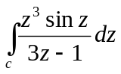 where C is the unit circle counterclockwise. 8
b) Define analytic function. Show that the function u(x,y)=3x²y+x²-y³-y² is a harmonic function. find a harmonic conjugate u of v 7
2. a) Evaluate 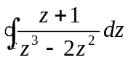 where c is the unit circle. 5
b) Find the Maclaurin's series of the function 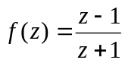 5
OR
Find the Laurent's series for 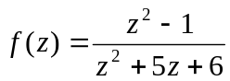 in the region 2<|z|<3.
c) Determine the location and order of the zeros of f(z) = tanπz 5
3. a) Using Cauchy Residue theorem, integrate: 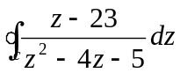 where c:|z-2|=4 counterclockwise. 8
b) Let f(x) be continuous and absolutely integral on the x-axis. Let f' (x) be piecewise continuous on each finite interval and let f(x)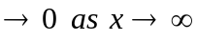then prove that
F_{c}[f'(x)] = wF_{s}[f(x)] - 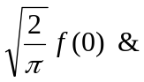
F_{s}[f'(x)] = -w F_{c} [f(x)] 7
4. a) Find the inverse Z-transform of 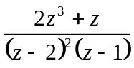 7
b Solve: 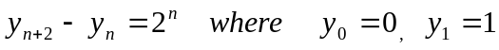 8
5. a) If F (z) and G(z) are respectively the z-transform of f(t) and g(t) then prove that Z 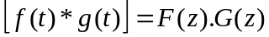 7
Or
Prove second shifting theorem of Z-transform ie if Z[f(t)=F(z) then Z[f(t+T)]=z[F(z)-f(0)]
b) Find fourier Sine and Cosine transform of 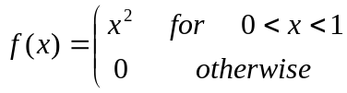 8
6. a) Find fourier transform of f(x) = 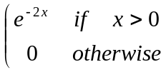 7

b) Show that 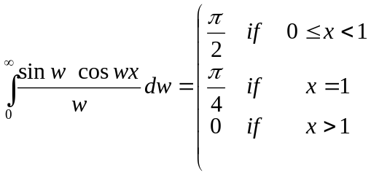 8
7. Attempt all:- 2*5
a) Express the function f(z)= e^{z} in the form of u+iv
b) Find the derivative of f(z)=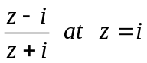
c) Prove Z(a^{n})= 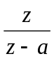
d) State and prove linearity property of Z-transform i.e Z[a f(t) +bg(t)] = aZ {f(t)} + bZ {g(t)}
e) Verify u =e^{x} siny satisfies two dimensional Laplace equation.

